NASA: Asteroids Classification

NASA’s Asteroids Classification Data Set: What Variables can be Hazardous to Earth?

By: Juan Villegas
MAT 342 Explorations in Data Science
Professor: Dr. Larose
01/05/2022

Table of Contents

NASA: Asteroids Classification 1
Table of Contents 2
Introduction: 3
Data Exploration: 4
How Graphical Displays Will Be Introduced: 5
Motion Mean Graphical Displays 6
Absolute Magnitude Graphical Displays 7
Est. Dia. In. KM. MIN Graphical Displays 9
Epoch.Date. Close.Approach Graphical Displays 11
Minimum Orbit Intersection Graphical Displays 14
Conclusion from Graphical Displays 15
Preparing to Model Data 15
Data Partitioning 16
Boxplots For 5 Variables 16
Baseline & Accuracy of Model (Training) 18
Baseline & Accuracy of Model (Testing) 19
Cart Models 20
10-fold Cross validation 20
Final Cart Model 21
Final CART Model comparisons to baseline and foreign data (Test data) 22
Conclusion 22
Appendix 23

Introduction:
This Data Science report will be conducted about Asteroids – NeoWs.
NeoWs (Near Earth Object Web Service) is a RESTful web service for near earth Asteroid information. With NeoWs users can: search for Asteroids based on their closest approach date to Earth, lookup specific Asteroids with its NASA JPL small body id, as well as browse the overall dataset. The goal of this data Science report is to classify, report, and find potential hazardous and non-hazardous asteroids.
The data used in this report is from the http://neo.jpl.nasa.gov/ website but, the actual data set was acquired using Kaggle.

Data Exploration:
The NASA data set has 40 variables that can be explored and tested to see if they can be Hazardous to Earth. In this report we will be focused on 6 specific numeric variables:
- Motion Mean
- Absolute Magnitude
- EST Día In KM Min
- Epoch Date Close Approach
- Minimum Orbit Intersection
First boxplots will be created for these variables created to see if there are any extreme outliers.
Regular outliers are calculated: Q1 - 1.5*IQR (Lower Fence) & Q3 + 1.5*IQR (Upper Fence)
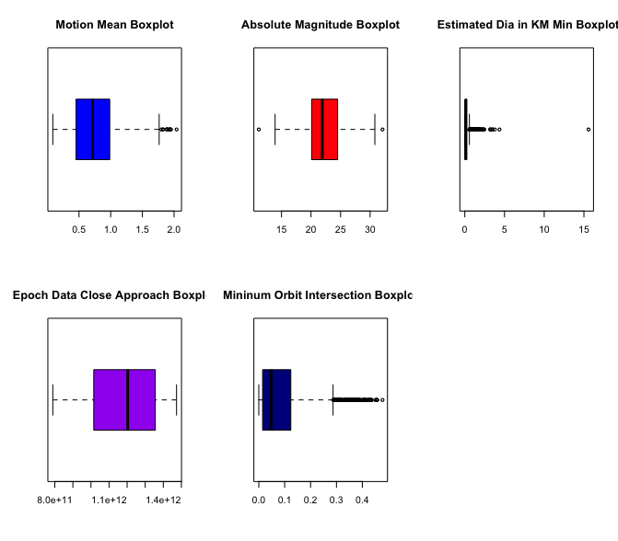
Extreme outliers are calculated: Q1 - 3*IQR (Lower Fence) & Q3 + 3*IQR (Upper Fence)
Figure 0. Figure 0 demonstrates 5 boxplots for the 5 variables that we are using in this report.
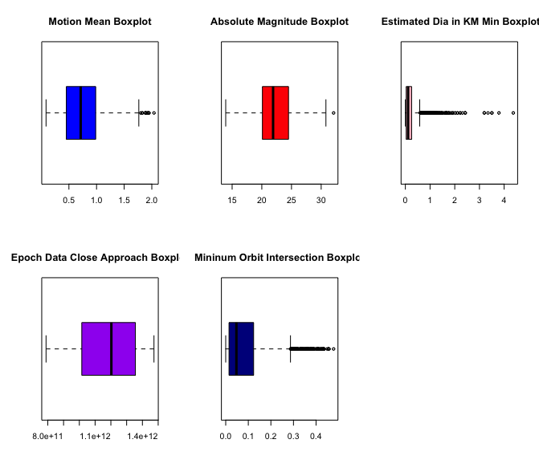
Looking at the Estimated Dia in KM Min Boxplot, it is easily distinguishable that there is an extreme outlier. This outlier will be removed to prevent extreme skewing of our data to the right.
Figure 1. Figure 1 shows the same boxplots as Figure 0 but, with the extreme outliers removed.
Now that the boxplots have been cleansed of extreme outliers… scatterplots, histograms, and density plots can be introduced.

How Graphical Displays Will Be Introduced:
The five variables that will be visualized will be: Motion Mean, Absolute Magnitude, EST Día In KM Min, Epoch Date Close Approach, and Minimum Orbit Intersection. The visualizations will be displayed in this order:
1st: A scatter plot
2nd: 3 of the same histograms but, with different positions
3rd: Binned Histograms (If Applicable)

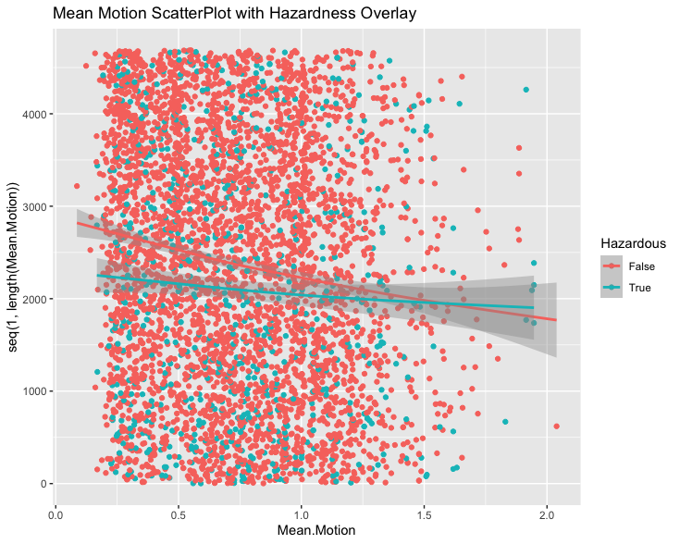
Motion Mean Graphical Displays
Figure 2. Figure 2 shows a scatterplot that is distributed by mean motion with hazardous overlay.
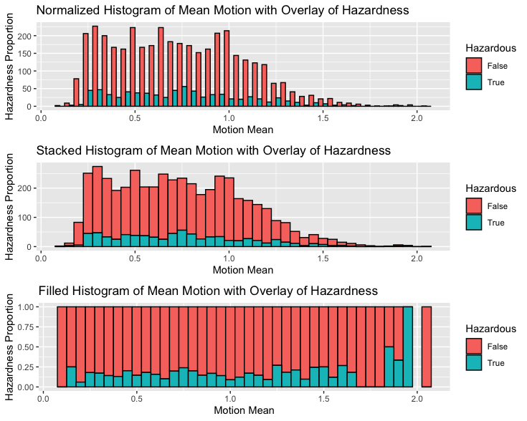
Figure 2 shows a scatterplot that shows one pattern: the dots are more condensed between the means .25 & 1.25. Let’s see if our histograms can give us more information.
Figure 3. Figure 3 shows histograms of Mean Motion in 3 different positions (1) Normalized, (2) Stacked, (3) Filled with hazardous overlay.
Looking at figure 3’s normalized histogram (1), it is inferred that most of the data is clumped up between .25 and 1.25. Transitioning to the stacked histogram (2), the image can be understood better. Asteroids that are hazardous have a unimodal shape between the .15 and 1.75 mean motion. Examining the filled histogram (3), shows that the variable mean motion does not influences an asteroids hazardness to earth with the Hazardness proportion being .25 or less for most of the dataset.

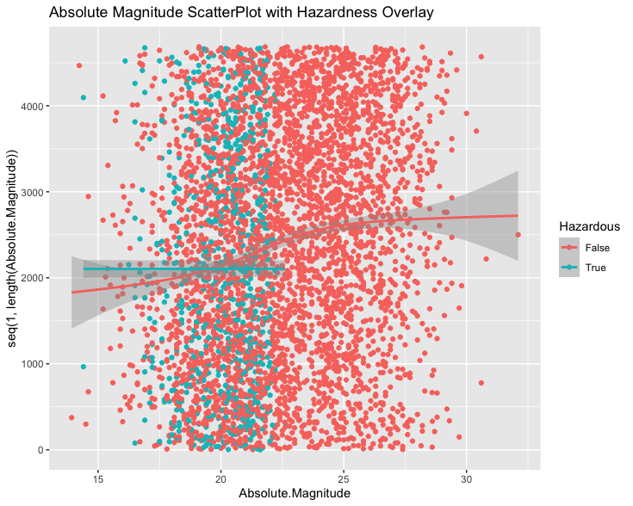
Absolute Magnitude Graphical Displays
Figure 4. Figure 4 shows a scatterplot that is distributed by Absolute Magnitude with an overlay of hazardous.

Figure 4 shows a scatterplot with an evident pattern when it comes to asteroids that are hazardous. The Asteroids that are hazardous seem to be very condensed in the absolute magnitude range of 12 and 22, After this max of 22, there looks like there is no hazardous asteroids. Let’s see if our Histograms give us more information.
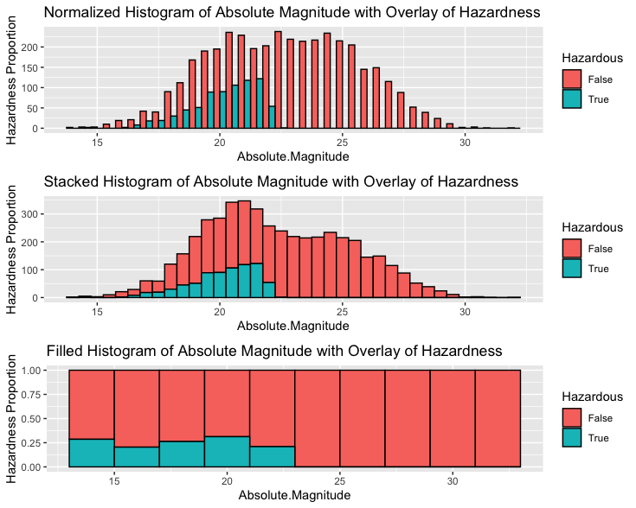
Figure 5. Figure 5 shows histograms of Absolute Magnitude in 3 different positions (1) Normalized, (2) Stacked, (3) Filled with hazardous overlay.
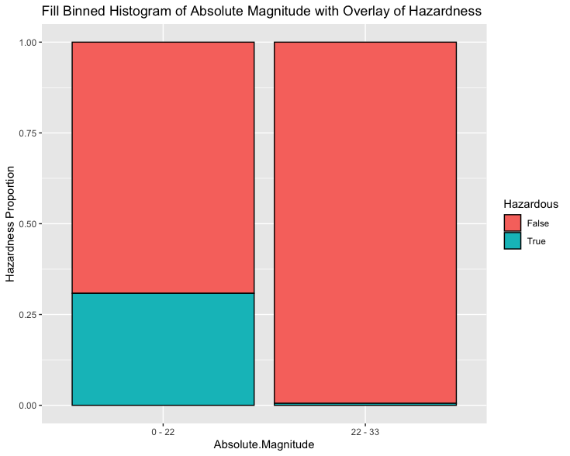
Figure 5’s normalized (1) and stacked (2) histogram show the left skewness of hazardous and non-hazardous asteroids. The filled histogram (3) zooms in this information & shows that after the Magnitude is 22, The asteroid is not hazardous to earth.
Figure 6. Figure 6 shows a filled binned histogram of Absolute Magnitude with hazardous overlay The binning is split between 0 – 22 & 22 - 33.
Figure 6 shows that the proportion of Asteroids in this data set that have an absolute magnitude between 0 – 22 have a about a .25 hazardous proportion. After 22 Absolute Magnitude, the proportion of being hazardous drops to almost 0.

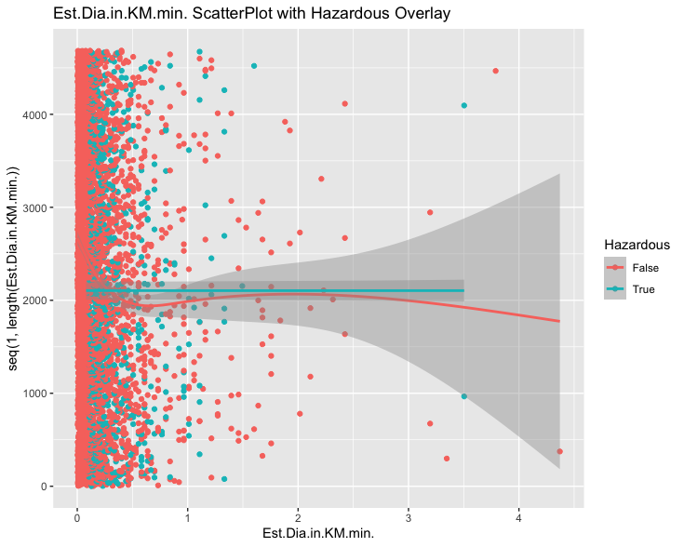
Est. Dia. In. KM. MIN Graphical Displays
Figure 7. Figure 7 shows a scatterplot that is distributed by Est. Dia. KM. Min with an overlay of hazardous.

Figure 7’s scatterplot does not have an evident pattern when it comes to asteroids that are hazardous. A majority of the non-hazardous are distributed between 0 and .5 for Est. Dia. KM. Min. Lets look at our histograms to see if we can see a pattern.
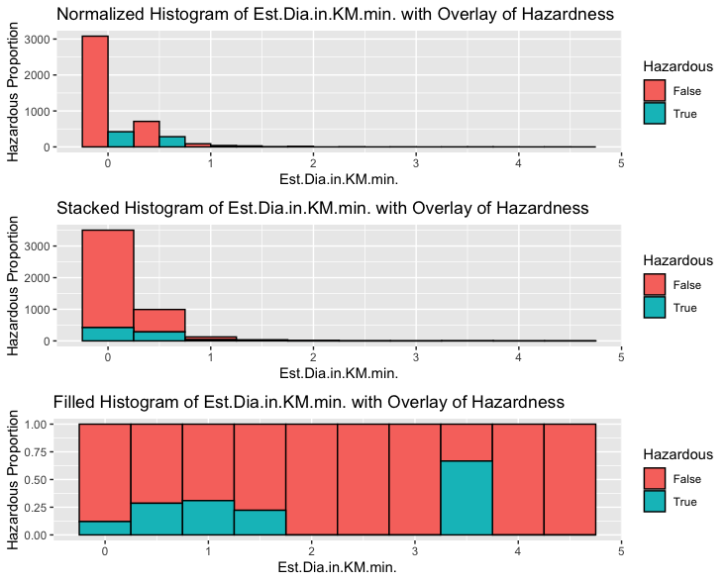
Figure 8. Figure 8 shows histograms of Est.Dia.in.KM.min in 3 different positions (1) Normalized, (2) Stacked, (3) Filled with hazardous overlay.
The normalized (1) and stacked (2) histogram from figure 8 don’t show much to talk about. Focusing on the stacked histogram (3) it is understood that between 0 and 1.5 Est.Dia.in.KM.min, there are asteroids that are hazardous until Est.Dia.in.KM.min is 4.5.
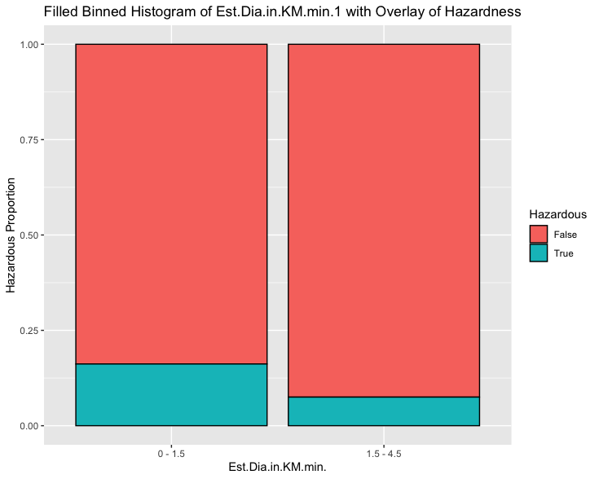
Figure 9. Figure 9 shows a filled binned histogram of Est.Dia.in.KM.min with hazardous overlay The binning is split between 0 – 22 & 22 - 33.
Figure 9 shows that, the hazardous proportions between an asteroid that is between 0 – 1.5 Est.Dia.in.KM.min doubles compared to an asteroid 1.5 - 4 Est.Dia.in.KM.min. The hazardous proportion compared to being non-hazardous is still relatively low with the highest proportion (0-1.5 Est.Dia.in.KM.min) being about .18.

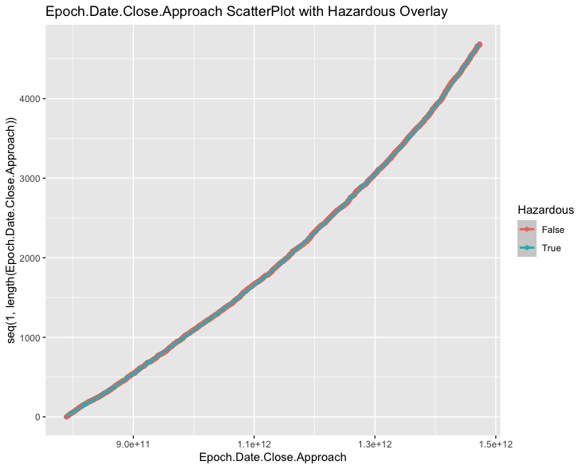
Epoch.Date. Close.Approach Graphical Displays
Figure 10. Figure 10 shows a scatterplot that is distributed by Epoch.Date.Close.Approach with hazardous overlay.
Figure 10’s scatterplot looks like an almost linear function and it’s exciting to wonder what it means. Let’s look at the histograms.

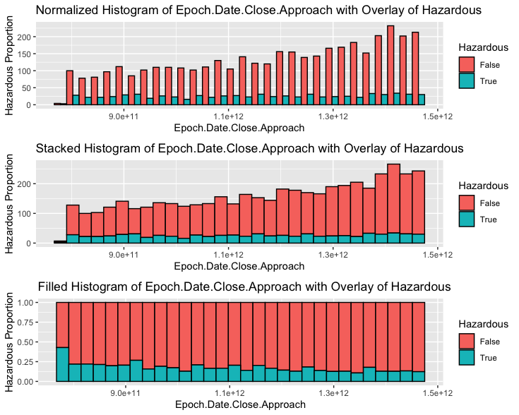
Figure 11. Figure 11 shows histograms of Epoch.Date.Close.Approach in 3 different positions (1) Normalized, (2) Stacked, (3) Filled with hazardous overlay.
Histogram (1) & (2) from figure 11 show a clear image of the information. The pattern that can be understood from these two histograms is that Figure 11 is pretty much a unimodal graph. Shifting attention to Histogram (3), The proportion of being hazardous is decreasing as epoch.Date.Close.Approach increases. Asteroids look to be more hazardous as epoch.Date.Close.Approach is lower. Looking at Histogram (3) might make one wonder whether, “Since all the hazardous bars are pretty unimodal throughout the histogram and higher in proportion, do this correlate to a higher proportion of hazardous asteroids?” Let’s see.

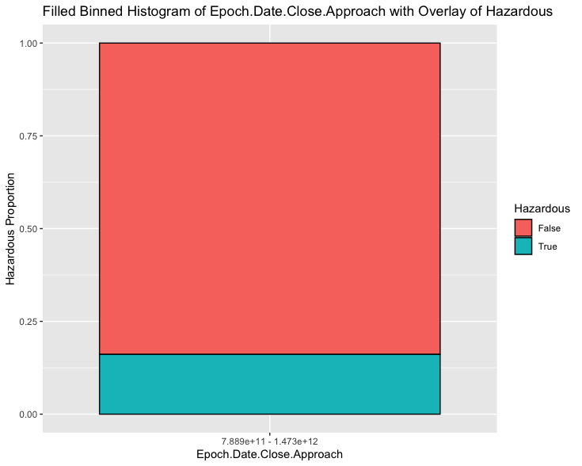
Figure 12. Figure 12 shows a filled binned histogram of Epoch.Date.Close.Approach with hazardous overlay The bin is 7.889e+11 - 1.473e+12 (Min to Max) to see a whole picture of the histogram.
Looking at Figure 12, the hypothesis that epoch.date.close.approach corresponds to a higher hazardous proportion is rejected. The hazardous proportion for epoch.date.close.approach is still less than .20. Which is not very significant.

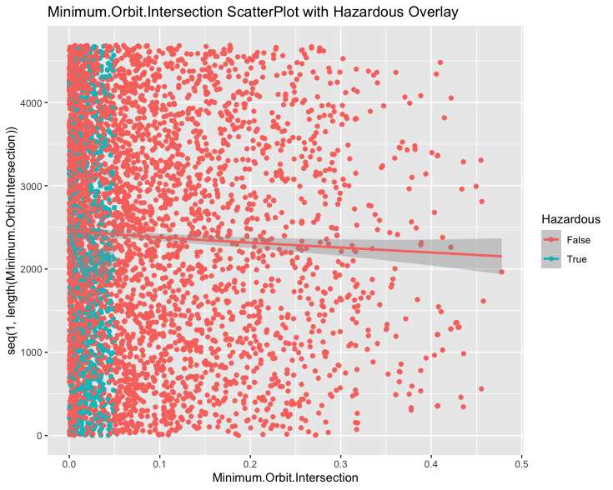
Minimum Orbit Intersection Graphical Displays
Figure 13. Figure 13 shows a scatterplot that is distributed by Minimum Orbit Intersection with hazardous overlay.
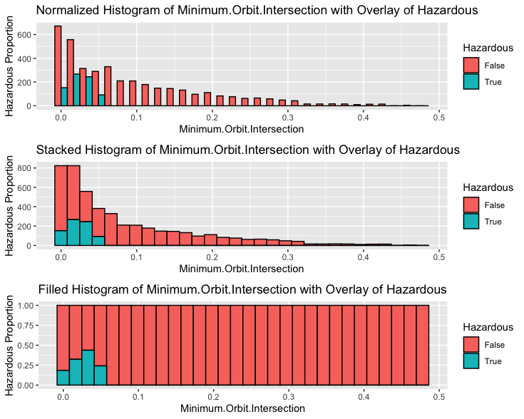
The Hazardous Asteroids in Figure 13 seem to all be between the minimum orbit intersection range of 0 - .05.
Figure 14. Figure 14 shows histograms of minimum Orbit Intersection in 3 different positions (1) Normalized, (2) Stacked, (3) Filled with hazardous overlay.
Figure 14 Histogram (1) & (2) show that non-hazardous asteroids are skewed right when it comes to minimum orbit intersection. In Histogram (3) it is emphasize that hazardous asteroids are only between the minimum orbit intersection of 0 - .06. After the minimum orbit intersection is greater than .06, there are no more hazardous asteroids.

Conclusion from Graphical Displays
Our graphical displays did not give us the most eye-catching information because there was no variable that was yelling, “Hey I have a high proportion of hazardous asteroids! Look at me!” All hazardous proportions were lower than .30. Although these variables did not give us any eye-catching info, it does reassure us that no specific variable is correlated with a high proportion of hazardous asteroids. This means that we must be diligent following this data. The variables I expect to see in our CART model are: Min.Orbit.Intersection, Est.Dia.in.Km.Min & Absolute Magnitude because of they held the higher hazardous proportions compared to all the graphs

Preparing to Model Data
What we want to do now is, create a Model that can create a decision tree where we see, from our data, what combinations of variables can correspond to hazardous asteroids. Before we can start the model, A few things must happen:
- Data Portioning
- Data Validating
- Create a Baseline & Accuracy of the model.

Data Partitioning
All the variables being tested in this report are numeric, this means 2 conditions must be met for the variables in the dataset to be validated: The training & test boxplots must look similar and Kruskal’s p-values must be greater than 0.1. The data will be partitioned 75% Training and 25% Testing. After this has been validated, the baseline & accuracy baseline will be proceeded.

Boxplots For 5 Variables
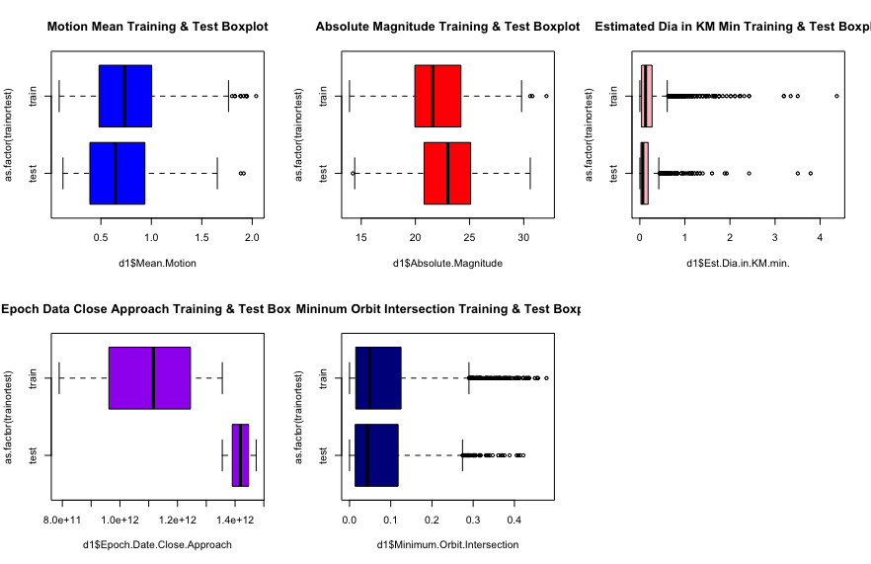
Figure 15. Figure 15 shows the boxplots for the 5 variables being validated. (1) Mean Motion Training & Test boxplot (2) Absolute Magnitude Training & Test boxplot (3) Estimated Dia in KM Min Training & Test boxplot (4) Epoch Data Close Approach Training & Test boxplot (5) Minimum Orbit Intersection Training & Test boxplot
Figure 15 meets the first condition for our validation of partitioning because the training & test boxplots for each of our variables are all similar. The next condition that must be met is Kruskals P-Value test.

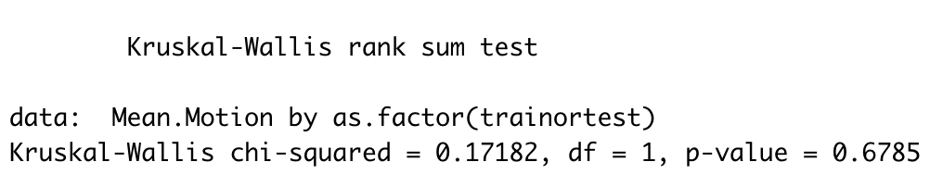 Figure 16. Figure 16 shows Kruskal’s Test for Mean Motion with the P-Value all the way to the right.

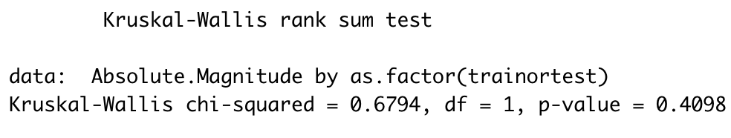 Figure 17. Figure 17 shows Kruskal’s Test for Absolute Magnitude with the P-Value all the way to the right.
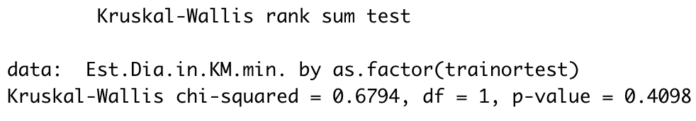 Figure 18. Figure 18 shows Kruskal’s Test for Est.Dia.in.KM.Min with the P-Value all the way to the right.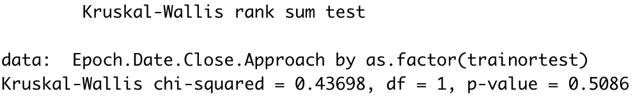 Figure 19. Figure 19 shows Kruskal’s Test for Epoch.Date.Close.Approach with the P-Value furthest to the right.
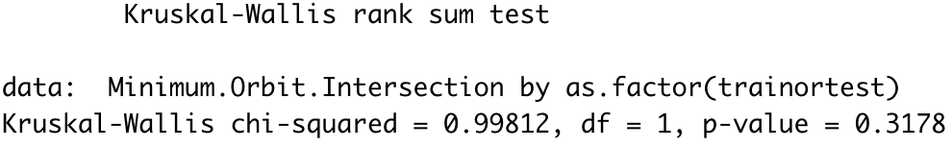 Figure 20. Figure 20 shows Kruskal’s Test for Minimum Orbit Intersection with the P-Value furthest right.
Figures 16 – 20 exemplify that the 5 variables pass the second condition for data partitioning. The P-Values for all variables range between 0.3178 & 0.6785 (All higher than 0.1).

Baseline & Accuracy of Model (Training)
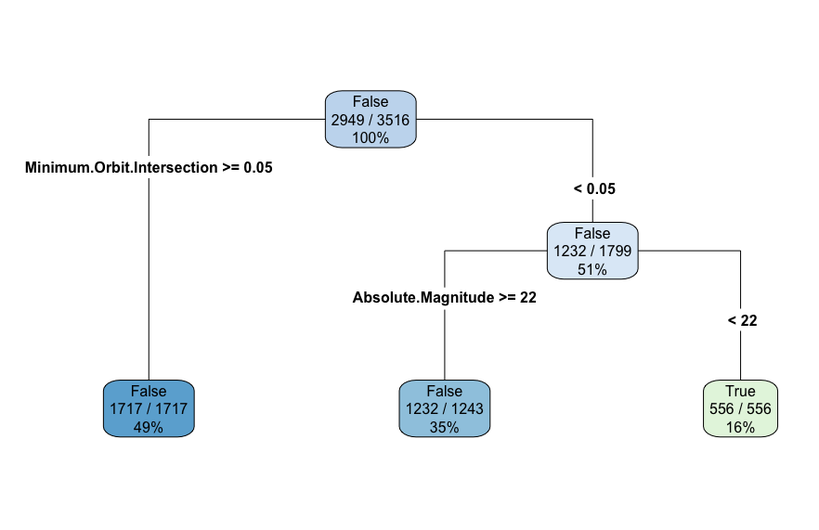
The Baseline model is determined from the 1st node that the CART model makes.
Figure 21. Figure 21 shows the default CART Model for Training Data that R created.

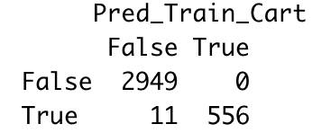
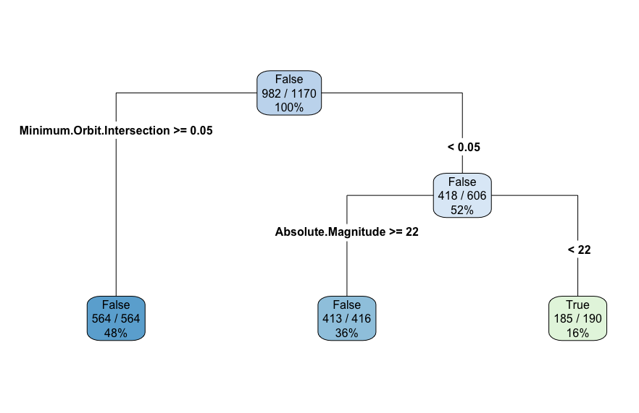
To get the Baseline of this model, look at the first node and the numbers that are being divided. The Baseline model is 0.8387372 (2949/3516) in other words 83.87%, which is not bad. Now, it is crucial to test the accuracy of the CART model. To do this, look at the table (to the right) that shows whether the asteroid is hazardous (True or False) on the prediction of the model. It’s simple to see the Asteroids that were correctly classified as false and true on the training prediction CART model. The Accuracy of this model is 0.9968714 ((2949+556)/3516) Which is 99.69%. The CART model’s accuracy is 0.1885384 ((0.9968714-0.8387372)/0.8387372) or 18.85% more than the baseline.

Baseline & Accuracy of Model (Testing)
Figure 22. Figure 22 shows the default CART Model for Testing Data that R created.

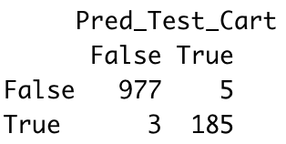
The Baseline model is 0.8393162 (982/1170) in other words 83.93%. The table of the Testing data (to the right) shows whether the asteroid is hazardous (True or False) on the prediction of the model (same as the Training table). The Accuracy of this model is 0.9931624 (1162/1170) Which is 99.32%. The CART model’s accuracy is 0.1832995 (0.9931624-.8393162)/.8393162) or 18.33% more than the baseline.

Cart Models
In the Data Partitioning part of this report, we created 2 cart models, training and test. These CART models gave the baseline and accuracy of the training and test data. Now focus will be shifted into creating a CART model that gives a good balance of accuracy and complexity. To do this, 10-fold cross validation needs to be done. 10-fold cross is a technique where R simultaneously creates CART models and then spits out a Complexity parameter for us to use.

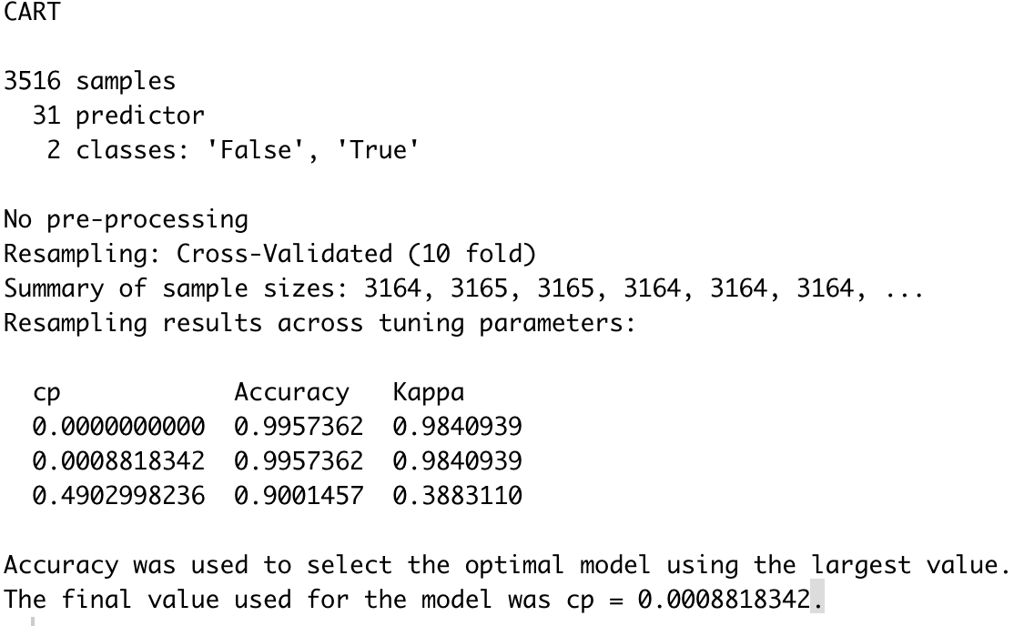
10-fold Cross validation
Figure 22. Figure 22 shows the default CART Model for Testing Data that R created.

Figure 22 gives us the output that R gives us. R shows that it resampled our data 10 times and that the final Complexity Parameter (CP) recommended is 0.0008818342.

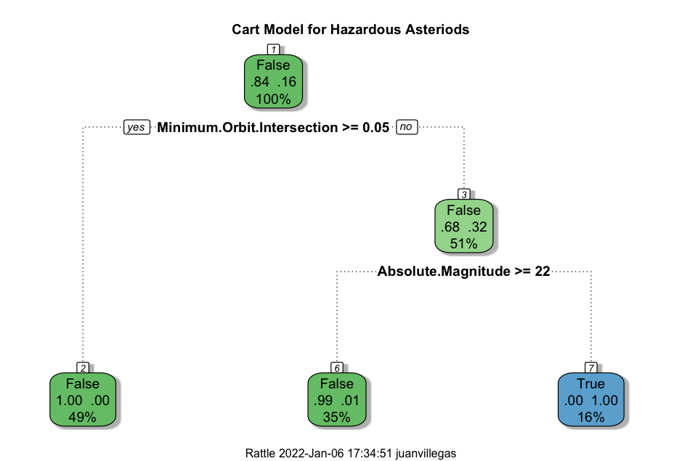
Final Cart Model
Figure 24. Figure 25 shows the Final CART Model

Figure 25 shows the CART model with the most balanced Complexity Parameter. It displays a good balance of complexity and accuracy compared to the last CART model. This CART model is read:
The CART model’s 1st leaf node is for hazardous asteroids. 84% of this entire dataset has non-hazardous asteroids while and 16% of asteroids are hazardous. CART decided to create a branch for if the asteroid has a minimum orbit intersection of .05 or greater. If it does have an intersection greater than .05, then CART creates another leaf nodes that indicates: 100% of these asteroids are non-hazardous. If the min orbit is smaller than .05, then a new node indicates that 68% of those asteroids are non-hazardous but 32% are hazardous. The next branch is if the absolute magnitude is greater than 22. If the absolute magnitude is more than 22 and the min orb is less than .05, the node says 99% these asteroids are non-hazardous. Asteroids with absolute magnitudes of less than 22 and min orbit with less than .05 have a node that show they are all hazardous. They are about 16% of our whole dataset.

Final CART Model comparisons to baseline and foreign data (Test data)
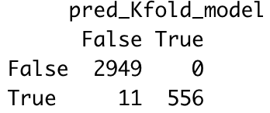
The baseline model of the final cart model is .84, or 84% (as shown in the first node). My CART model outperformed the baseline model (1st node) by 18.67%. (2949+556 = 3505 –> 3505/3516 = 0.9968714 –> 9968714-.84)/.84 = 0.1867517) (use the table on the right to see where I got these #’s.)
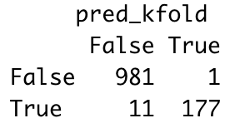
Now testing the Final CART model for accuracy against foreign (our testing data) data, we get 98.97% accuracy. (981+177 = 1158 –> 1158/1170 = 0.9897436) (Use the table to the right to see how I used my equation above this line)

Conclusion
From this report, I was able to almost perfectly predict the variables that were going to be in the CART model from looking at the graphical displays. Est.Dia.inKM.min didn’t make the cut but, I’m perfectly fine with that. To conclude this report, it is understood that 16% of all asteroids are considered hazardous. This is great news for me because this low probability of hazardous asteroids gives me hope that I’ll be able to continue to spend my winter break free time on finishing this incomplete course 😬.

Appendix
Juan Villegas
1/6/2022
’’’{r} #Prelude d <- nasa d <- d[,-c(1, 2, 12, 21:24, 39) ] d$Hazardous<-as.factor(d$Hazardous) summary(d) #Boxplots par(mfrow=c(2,3)) boxplot(d$Mean.Motion, horizontal = TRUE, main = "Motion Mean Boxplot", col = "blue") boxplot(d$Absolute.Magnitude, horizontal = TRUE, main = “Absolute Magnitude Boxplot”, col = “red”) boxplot(d$Est.Dia.in.KM.min., horizontal = TRUE, main = " Estimated Dia in KM Min Boxplot", col = "pink") boxplot(d$Epoch.Date.Close.Approach, horizontal = TRUE, main = “Epoch Data Close Approach Boxplot”, col = “purple” ) boxplot(d$Minimum.Orbit.Intersection, horizontal = TRUE, main = "Mininum Orbit Intersection Boxplot", col = "darkblue") d1 <- d[-c(1717), ] par(mfrow=c(2,3)) boxplot(d1$Mean.Motion, horizontal = TRUE, main = “Motion Mean Boxplot”, col = “blue”) boxplot(d1$Absolute.Magnitude, horizontal = TRUE, main = "Absolute Magnitude Boxplot", col = "red") boxplot(d1$Est.Dia.in.KM.min., horizontal = TRUE, main = " Estimated Dia in KM Min Boxplot“, col =”pink“) boxplot(d1$Epoch.Date.Close.Approach, horizontal = TRUE, main = "Epoch Data Close Approach Boxplot", col = "purple" ) boxplot(d1$Minimum.Orbit.Intersection, horizontal = TRUE, main =”Mininum Orbit Intersection Boxplot“, col =”darkblue")
#Mean Motion & Hazardous M1 <- ggplot(d1, aes(Mean.Motion)) + geom_histogram(aes(fill = Hazardous), color = “black”, binwidth = .05, position = “dodge”) + xlab(“Motion Mean”) + ylab(“Hazardness Proportion”) + ggtitle(“Normalized Histogram of Mean Motion with Overlay of Hazardness”) M2 <- ggplot(d1, aes(Mean.Motion)) + geom_histogram(aes(fill = Hazardous), color = “black”, binwidth = .05, position = “stack”) + xlab(“Motion Mean”) + ylab(“Hazardness Proportion”) + ggtitle(“Stacked Histogram of Mean Motion with Overlay of Hazardness”) M3 <- ggplot(d1, aes(Mean.Motion)) + geom_histogram(aes(fill = Hazardous), color = “black”, binwidth = .05, position = “fill”) + xlab(“Motion Mean”) + ylab(“Hazardness Proportion”) + ggtitle(“Filled Histogram of Mean Motion with Overlay of Hazardness”) ggplot(d1, aes(x = Mean.Motion, color = Hazardous, y = seq(1, length(Mean.Motion)))) + geom_point() +geom_smooth() + labs(title = “Mean Motion ScatterPlot with Hazardness Overlay”) #ggplot(d1, aes(x = Mean.Motion, fill = Hazardous)) +geom_density(alpha = 0.4) +labs(title = “Mean Motion Density distribution by Hazardness”) grid.arrange(M1,M2,M3) #Absolute Magnitude & Hazardess ggplot(d1, aes(x = Absolute.Magnitude, color = Hazardous, y = seq(1, length(Absolute.Magnitude)))) + geom_point() +geom_smooth() + labs(title = “Absolute Magnitude ScatterPlot with Hazardness Overlay”) #ggplot(d1, aes(x = Absolute.Magnitude, fill = Hazardous)) +geom_density(alpha = 0.4) +labs(title = “Mean Motion Density distribution by Hazardness”) A1 <- ggplot(d1, aes(Absolute.Magnitude)) + geom_histogram(aes(fill = Hazardous), color = “black”, binwidth = .5, position = “dodge”) + xlab(“Absolute.Magnitude”) + ylab(“Hazardness Proportion”) + ggtitle(“Normalized Histogram of Absolute Magnitude with Overlay of Hazardness”) A2 <- ggplot(d1, aes(Absolute.Magnitude)) + geom_histogram(aes(fill = Hazardous), color = “black”, binwidth = .5, position = “stack”) + xlab(“Absolute.Magnitude”) + ylab(“Hazardness Proportion”) + ggtitle(“Stacked Histogram of Absolute Magnitude with Overlay of Hazardness”) A3 <- ggplot(d1, aes(Absolute.Magnitude)) + geom_histogram(aes(fill = Hazardous), color = “black”, binwidth = 1, position = “fill”) + xlab(“Absolute.Magnitude”) + ylab(“Hazardness Proportion”) + ggtitle(“Filled Histogram of Absolute Magnitude with Overlay of Hazardness”) grid.arrange(A1,A2,A3) summary(d1$Absolute.Magnitude)
d1$Absolute.Magnitude1<-cut(d1$Absolute.Magnitude, breaks = c(-.01,22,33), labels = c(“0 - 22”,“22 - 33”)) A33 <- ggplot(d1, aes(Absolute.Magnitude1)) + geom_bar(aes(fill = Hazardous), color = “black”, position = “fill”) + xlab(“Absolute.Magnitude”) + ylab(“Hazardness Proportion”) + ggtitle(“Fill Binned Histogram of Absolute Magnitude with Overlay of Hazardness”) #Est.Dia.In.KM.MIN & Hazardous ggplot(d1, aes(x = Est.Dia.in.KM.min., color = Hazardous, y = seq(1, length(Est.Dia.in.KM.min.)))) + geom_point() +geom_smooth() + labs(title = “Est.Dia.in.KM.min. ScatterPlot with Hazardous Overlay”) #ab_Density <- ggplot(d1, aes(x = Est.Dia.in.KM.min., fill = Hazardous)) +geom_density(alpha = 0.4) +labs(title = “Est.Dia.in.KM.min. Density distribution by Hazardness”) E1 <- ggplot(d1, aes(Est.Dia.in.KM.min.)) + geom_histogram(aes(fill = Hazardous), color = “black”, binwidth = .5, position = “dodge”) + xlab(“Est.Dia.in.KM.min.”) + ylab(“Hazardous Proportion”) + ggtitle(“Normalized Histogram of Est.Dia.in.KM.min. with Overlay of Hazardness”) E2 <- ggplot(d1, aes(Est.Dia.in.KM.min.)) + geom_histogram(aes(fill = Hazardous), color = “black”, binwidth = .5, position = “stack”) + xlab(“Est.Dia.in.KM.min.”) + ylab(“Hazardous Proportion”) + ggtitle(“Stacked Histogram of Est.Dia.in.KM.min. with Overlay of Hazardness”) E3 <- ggplot(d1, aes(Est.Dia.in.KM.min.)) + geom_histogram(aes(fill = Hazardous), color = “black”, binwidth = .5, position = “fill”) + xlab(“Est.Dia.in.KM.min.”) + ylab(“Hazardous Proportion”) + ggtitle(“Filled Histogram of Est.Dia.in.KM.min. with Overlay of Hazardness”) grid.arrange(E1,E2,E3) summary(d1$Est.Dia.in.KM.min.)d1$Est.Dia.in.KM.min.1 <- cut(d1$Est.Dia.in.KM.min., breaks = c(-.01,1.5,5.5), labels = c("0 - 1.5","1.5 - 4.5")) E33 <- ggplot(d1, aes(Est.Dia.in.KM.min.1)) + geom_bar(aes(fill = Hazardous), color = "black", position = "fill") + xlab("Est.Dia.in.KM.min.") + ylab("Hazardous Proportion") + ggtitle("Filled Binned Histogram of Est.Dia.in.KM.min.1 with Overlay of Hazardness") #d. Epoch.Date.Close.Approach & Hazardous ggplot(d1, aes(x = Epoch.Date.Close.Approach, color = Hazardous, y = seq(1, length(Epoch.Date.Close.Approach)))) + geom_point() +geom_smooth() + labs(title = "Epoch.Date.Close.Approach ScatterPlot with Hazardous Overlay") #ab_Density <- ggplot(d1, aes(x = Epoch.Date.Close.Approach, fill = Hazardous)) +geom_density(alpha = 0.4) +labs(title = "Est.Dia.in.KM.min. Density distribution by Hazardness") D2 <- ggplot(d1, aes(Epoch.Date.Close.Approach)) + geom_histogram(aes(fill = Hazardous), color = "black", position = "dodge") + xlab("Epoch.Date.Close.Approach") + ylab("Hazardous Proportion") + ggtitle("Normalized Histogram of Epoch.Date.Close.Approach with Overlay of Hazardous") D3 <- ggplot(d1, aes(Epoch.Date.Close.Approach)) + geom_histogram(aes(fill = Hazardous), color = "black", position = "stack") + xlab("Epoch.Date.Close.Approach") + ylab("Hazardous Proportion") + ggtitle("Stacked Histogram of Epoch.Date.Close.Approach with Overlay of Hazardous") D4 <- ggplot(d1, aes(Epoch.Date.Close.Approach)) + geom_histogram(aes(fill = Hazardous), color = "black", position = "fill") + xlab("Epoch.Date.Close.Approach") + ylab("Hazardous Proportion") + ggtitle("Filled Histogram of Epoch.Date.Close.Approach with Overlay of Hazardous") grid.arrange(D2,D3,D4) summary(d1$Epoch.Date.Close.Approach) d1$Epoch.Date.Close.Approach1<-cut(d1$Epoch.Date.Close.Approach, breaks = c(7.889e+11,1.473e+13 ), labels = c(“7.889e+11 - 1.473e+12”)) ggplot(d1, aes(Epoch.Date.Close.Approach1)) + geom_bar(aes(fill = Hazardous), color = “black”, position = “fill”) + xlab(“Epoch.Date.Close.Approach”) + ylab(“Hazardous Proportion”) + ggtitle(“Filled Binned Histogram of Epoch.Date.Close.Approach with Overlay of Hazardous”)
#e. Minimum.Orbit.Intersection & Hazardous ggplot(d1, aes(x = Minimum.Orbit.Intersection, color = Hazardous, y = seq(1, length(Minimum.Orbit.Intersection)))) + geom_point() +geom_smooth() + labs(title = “Minimum.Orbit.Intersection ScatterPlot with Hazardous Overlay”) #ab_Density <- ggplot(d1, aes(x = Minimum.Orbit.Intersection, fill = Hazardous)) +geom_density(alpha = 0.4) +labs(title = “Est.Dia.in.KM.min. Density distribution by Hazardness”) N1 <- ggplot(d1, aes(Minimum.Orbit.Intersection)) + geom_histogram(aes(fill = Hazardous), color = “black”, position = “dodge”) + xlab(“Minimum.Orbit.Intersection”) + ylab(“Hazardous Proportion”) + ggtitle(“Normalized Histogram of Minimum.Orbit.Intersection with Overlay of Hazardous”) N2 <- ggplot(d1, aes(Minimum.Orbit.Intersection)) + geom_histogram(aes(fill = Hazardous), color = “black”, position = “stack”) + xlab(“Minimum.Orbit.Intersection”) + ylab(“Hazardous Proportion”) + ggtitle(“Stacked Histogram of Minimum.Orbit.Intersection with Overlay of Hazardous”) N3 <- ggplot(d1, aes(Minimum.Orbit.Intersection)) + geom_histogram(aes(fill = Hazardous), color = “black”, position = “fill”) + xlab(“Minimum.Orbit.Intersection”) + ylab(“Hazardous Proportion”) + ggtitle(“Filled Histogram of Minimum.Orbit.Intersection with Overlay of Hazardous”) grid.arrange(N1,N2,N3)
#Data Partitioning library(caret) set.seed(169)
InTrain <- createDataPartition(y = d1$Hazardous, p= .75, list = FALSE)
Train_Data <- d1[InTrain,]
Test_Data <- d1[-InTrain,]
Train_Data$trainortest <- rep("train", nrow(Train_Data)) Test_Data$trainortest <- rep(“test”, nrow(Test_Data)) All_Data <- rbind(Train_Data, Test_Data)
#Boxplots par(mfrow=c(2,3))
boxplot(d1$Mean.Motion ~as.factor(trainortest), data = All_Data, horizontal = TRUE, main = "Motion Mean Training & Test Boxplot", col = "blue") boxplot(d1$Absolute.Magnitude ~ as.factor(trainortest), data = All_Data, horizontal = TRUE, main = “Absolute Magnitude Training & Test Boxplot”, col = “red”) boxplot(d1$Est.Dia.in.KM.min.~ as.factor(trainortest), data = All_Data, horizontal = TRUE, main = " Estimated Dia in KM Min Training & Test Boxplot", col = "pink") boxplot(d1$Epoch.Date.Close.Approach~ as.factor(trainortest), data = All_Data, horizontal = TRUE, main = “Epoch Data Close Approach Training & Test Boxplot”, col = “purple” ) boxplot(d1$Minimum.Orbit.Intersection~ as.factor(trainortest), data = All_Data, horizontal = TRUE, main = “Mininum Orbit Intersection Training & Test Boxplot”, col = “darkblue”)
#Mean Motion boxplot(Mean.Motion ~ as.factor(trainortest), data = All_Data) kruskal.test(Mean.Motion ~ as.factor(trainortest), data = All_Data)
#Absolute Magnitude boxplot(Absolute.Magnitude ~ as.factor(trainortest), data = All_Data) kruskal.test(Absolute.Magnitude ~ as.factor(trainortest), data = All_Data)
#Est.Dia.in.KM.Min boxplot(Est.Dia.in.KM.min. ~ as.factor(trainortest), data = All_Data) kruskal.test(Est.Dia.in.KM.min. ~ as.factor(trainortest), data = All_Data)
#Epoch.Date.Close.Approach boxplot(Epoch.Date.Close.Approach ~ as.factor(trainortest), data = All_Data) kruskal.test(Epoch.Date.Close.Approach ~ as.factor(trainortest), data = All_Data)
#minimum.orbit.intersection boxplot(Minimum.Orbit.Intersection ~ as.factor(trainortest), data = All_Data) kruskal.test(Minimum.Orbit.Intersection ~ as.factor(trainortest), data = All_Data)
#Remove Test & Training data names(Train_Data) Train_Data <- Train_Data[,-33:-36] names(Train_Data)
names(Test_Data) Test_Data <- Test_Data[,-33:-36] names(Test_Data)
#Training CART Baseline and model Testing
Train_Cart <- rpart(Hazardous ~., data = Train_Data, method = “class”)
rpart.plot(Train_Cart,type = 4, extra = 102) #Baseline Model = 1st node 2949/3516 #Testing the accuracy of the model on the training data Pred_Train_Cart <- predict(object = Train_Cart, newdata = Train_Data, type = “class”) table(Train_Data$Hazardous, Pred_Train_Cart) dim(Train_Data)[1] (2949+556)/3516 (0.9968714-0.8387372)/0.8387372
#Testing Cart Model baseline & Accuracy Test_Cart <- rpart(Hazardous ~., data = Test_Data, method = “class”) rpart.plot(Test_Cart,type = 4, extra = 102) #Baseline Model (1st Node) 982/1170#=0.8393162
Pred_Test_Cart <- predict(object = Test_Cart, newdata = Test_Data, type = “class”) table(Test_Data$Hazardous, Pred_Test_Cart)
977+185 #= 1162
dim(Test_Data)[1] # = 1170
1162/1170 # = 0.9931624
(0.9931624-.8393162)/.8393162
#K-Fold Cross Validation set.seed(134)
Train_Control <- trainControl(method = “cv”, number = 10)
Train_Data_CCA <- na.omit(Train_Data) model <- train(Hazardous ~. , data = Train_Data_CCA, method = “rpart”, trControl = Train_Control) print(model) #This helped us find our cp (complexity Parameter) #. This # gives us a good balance between accuracy & complexity. #This means we’re not plotting every single data point (Making a crazy complex model) but, we are taking the most useful data points to plot a model.
plot(model$finalModel)
text(model$finalModel) library(rattle) #Use Package Rattle to plot the final model fancyRpartPlot(model$finalModel, cex = 1.2, main = “Cart Model for Hazardous Asteriods”)
?fancyRpartPlot
#Now lets look at how it performs:
pred_Kfold_model <- rpart.predict(object = model, newdata = Train_Data) table(Train_Data$Hazardous,pred_Kfold_model)
Check for accuracy:
2949+556 # = 3505 dim(Train_Data)[1] #3516
3505/3516 # = 0.9968714
#how it outpreformed the baseline model (.9968714-.84)/.84
Now its performance for things its never seen (use testing data)
pred_kfold <- rpart.predict(object = model, newdata = Test_Data) table(Test_Data$Hazardous, pred_kfold)
981+177 # = 1158
dim(Test_Data)[1] # = 1170
1158/1170 # = 0.9897436 ’’’

